Victoria Oliver
April 21, 2015
Race and Ethnicity
Professor Smith
Influence of International Women in America
Keywords: Women, Immigration, Female Employment, Women and Education, Migrants
Description: This issue brief is meant to address the female immigrant population and their experiences in United States society. Covering topics ranging from education to socio-economic status, the brief describes the number of female immigrants in the United States, reasons for female immigration, and the variety of careers female immigrants occupy. Ultimately, female immigrants have successfully integrated into American culture and contribute significantly to American society.
Key Points:
- There about 20 million female immigrants in the United States
- Female immigrants make up 13 % of the overall female population in the United States.
- Mexico is the leading country when it comes to female immigration
- About 27 % of female immigrants have at least a bachelor’s degree or have achieved higher levels of education.
- The main reason women migrate to the United States is to avoid being separated from their families
- Female immigrants make up 15% of the female workforce in the United States.
Websites:
http://www.pbs.org/itvs/thecity/immigration4.html
https://www.americanprogress.org/issues/immigration/news/2012/03/07/11200/10-facts-you-need-to-know-about-immigrant-women
http://www.migrationpolicy.org/article/immigrant-women
http://immigrationimpact.com/2015/03/09/immigrant-women-contribute-u-s-economy/

Images:
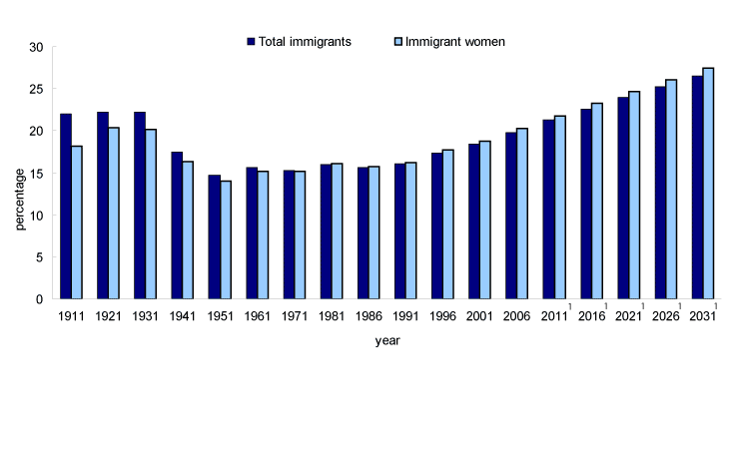
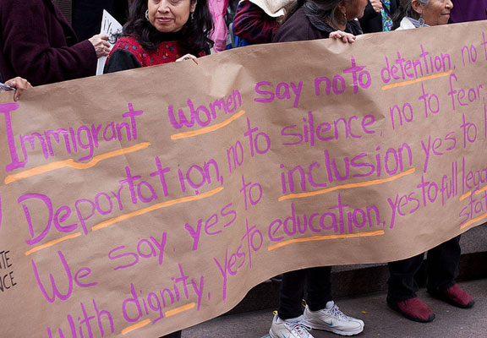

Brief:
The women immigrant population in America is about 20 million in size, which greatly exceeds the male immigrant population. Immigrant women come from all over the world including countries such as the Philippines, India, El Salvador, Vietnam, Nigeria, Mexico, and more. The large number of women immigrants results in them having a significant impact in United States society and economy. Almost half of the female immigrant population are naturalized and become U.S. Citizens. About 25% of female immigrants have a college education or higher, enabling them to make up about 15 % of the female workforce in the United States. Female immigrants occupy a variety of careers ranging from white collar to blue collar occupations. About 1/3 of the female immigrant population have management positions, another 1/3 occupy service careers, and about 25% work in sales. Although many female immigrants have high work ethic and the academic qualifications, ultimately they receive a lower salary than foreign-born men as well as native-born men and women for equal work.
Mexico is the leading country when it comes to the origin of women immigration, accounting for about 25 % of female immigration. China is the 2nd largest country regarding female immigration, coming in at 6.1 %. The Philippines is the native country to about 5.3 % of the female immigrant population and India is fourth regarding female immigration with 4.5 % of female migrants. All other countries provide about 59 % of the female foreign-born population in the United States.
Female immigrants make up 13 % of the overall female population in the United States and 51.3 % of the migrant population in the United States, barely outnumbering male migrants. Male migrants do however exceed female migrants in number from the countries of Mexico, India, El Salvador, and Guatemala, while female immigrants outnumber males from, the Philippines, China, Vietnam, the Dominican Republic, Cuba, and Canada.
Women are more likely to migrate than men due to family-related circumstances. Females gain legal permanent resident status through the family-based class of admissions, while men usually gain residency through employment-related circumstances. About 394,384 female immigrants obtained legal permanent residence due to family –related circumstances compared to the 286,393 men, who migrated for the same reason, while 73,312 men received legal permanent residence for employment compared to 70,684 women. According to interviews conducted by New America Media, the reason female immigrants give for wanting to become United States citizens are: “‘to make sure I’m never separated from my children’ (24 %), to be able to vote (21 %), and to be able to live in the United States for the rest of their lives (16 %).” (American Immigration Council 5) Ultimately, immigrant women are more likely to be naturalized as U.S. Citizens than men.
About 27 % of immigrant women have at least a bachelor’s degree or have achieved higher levels of education. This percentage of highly educated foreign-born females just barely falls short to the 29.4 % of native- born women and 28.4 % of immigrant males that have obtained bachelor’s degrees or higher. Educational achievements of immigrant women usually vary depending on their country of origin. 71.6 % of female immigrants from India have achieved a bachelor’s degree or more, making India the number one country of origin regarding highly educated women migrants. India is followed by the Philippines, which comes in at 52 %, and China, which comes in at about 47 %. Compared to the male immigrant population in 6 out of 10 of the top countries of origin of immigration, there are a higher number of female immigrants with bachelor’s degree and higher levels of education than men.
About 56.4 % of foreign-born women are employed in the United States, making up about 15 % of employed women overall. Women immigrants make up 20 % of the business owner population in America. Despite their high education, achievements, and qualifications, immigrant women in the labor force earn less than any other demographic. Immigrant women had an average salary of $32,015, immigrant men make $36,802, native-born American women earn $38,514, and American men make $50,283 annually. “In all top 10 countries of origin, immigrant men in the labor force earned more than immigrant women in the labor ”(American Immigration Council 15).

Works Cited
Batalova, Jeanna. "10 Facts You Need to Know About Immigrant Women." Name. N.p., n.d. Web. 02 Mar. 2015. <https://www.americanprogress.org/issues/immigration/news/2012/03/07/11200/10-facts-you-need-to-know-about-immigrant-women/>.
"How Immigrant Women Contribute to the U.S. Economy." Immigration Impact. N.p., 09 Mar. 2015. Web. 21 Apr. 2015. <http://immigrationimpact.com/2015/03/09/immigrant-women-contribute-u-s-economy/>.
"Immigrant Women." Migrationpolicy.org. N.p., 22 May 2002. Web. 21 Apr. 2015. <http://www.migrationpolicy.org/article/immigrant-women>.
"Immigrant Women in the United States: A Portrait of Demographic Diversity."
Immigrant Women in the United States: A Portrait of Demographic Diversity. N.p., n.d. Web. 26 Feb. 2015.
N.p., n.d. Web. 21 Apr. 2015.
<http://blogs-images.forbes.com/womensenews/files/2012/07/immigrant-women- protest_0.jpg>.
N.p., n.d. Web. 21 Apr. 2015.
<http://www.statcan.gc.ca/pub/89-503-x/2010001/article/11528/c-g/c-g001- eng.gif>.
PBS. PBS, n.d. Web. 02 Mar. 2015. <http://www.pbs.org/itvs/thecity/immigration4.html>.

